¿ME SI-GAY O NO ME SI-GAY TODAVIA?: VARIANCE IN LATIN AMERICAN LGBTQ RIGHTS AND PROTECTIONS

James “Jim” Milton Moore IV
©2020

A thesis presented in partial fulfillment of the requirements for completion of the
Bachelor of Arts degree in International Studies
Croft Institute for International Studies
University of Mississippi

Oxford, Mississippi
April 2020

Approved by:

________________________________
Advisor: Dr. Kate Centellas

________________________________
Reader: Dr. Oliver Dinius

________________________________
Reader: Dr. Diane Marting

ACKNOWLEDGEMENTS
“There may be times when we are powerless to prevent injustice, but there must never be a time when we fail to protest”

—Elie Wiesel, 1986

First, I would like to acknowledge the patience and dedication of Dr. Kate Centellas—my advisor for this project. I deeply appreciate the commitment and seriousness that she has shown while helping to guide this project. Her influence in my academic career is tremendous and she has helped to mold me into the student and the person I have become since meeting her nearly four years ago. I will be forever grateful to her as both an advisor and mentor.
Next, I would like to acknowledge Dr. Oliver Dinius and Dr. Diane Marting—my second and third readers for this project. I have to extend extra thanks to Dr. Marting for her wisdom and library of resources—all of which were key in the success of this project.
Additionally, I would like to extend my sincere thanks to the Croft Institute for International Studies—including all of its faculty and staff—for supporting me in this project and throughout my undergraduate career. I am fortunate to have been able to study under and work alongside all who walk its halls. I would also like to acknowledge my friends from the Croft Institute for their unwavering support. I am especially grateful to Millie Morse, Gabbi Schust, Maddie Gegg, William Boyd, and Susannah Cassisa.
I would be remiss to not acknowledge the women of Beanland Drive, their patience, love, and support. Thank you, to Meredith Moore, Maddie Pruitt, and Charlotte McGuire.
I also wish to offer thanks to Dr. María Otero (University of Mississippi), Dr. Calla Hummel (University of Miami), and Dr. Daniel Jones (Universidad de Buenos Aires).
Finally, I would like to acknowledge my family who, though they may not know it, continue to inspire and encourage me.

ABSTRACT
“Never doubt that a small group of thoughtful, committed, citizens can change the world. Indeed, it is the only thing that ever has”

—Margaret Mead, n.d.

Progress in LGBTQ rights and protections have been made unevenly across much of the world, and few regions have embraced LGBTQ rights with as much variance as Latin America. Within the region, there exists an asymmetrical relationship between developments in legislation and policy and improvements in social and cultural attitudes towards queer and genderqueer individuals. This project begins by providing a brief overview of the domestic and international factors which have incited the variance of Latin America’s LGBTQ rights and protections—specifically the pink tide, transnationalism, constitutional reforms, and activism. It then transitions into a brief overview of Argentina and Mexico’s respective LGBTQ histories, the two case studies for this project. In line with explaining some of the causes of the region’s variance, I present this variance through The Latin American LGBTQ Rights and Protections Index—a multivariate index which categorically examines LGBTQ legislation and policy in Latin America’s Spanish- and Portuguese-speaking countries.

Key Terms: LGBTQ, queer, genderqueer, comparative politics, Argentina, Mexico, Latin America, The Latin American LGBTQ Rights and Protections Index, pink tide, transnationalism, constitutional reform, activism, human rights, civil rights, social justice

TABLE OF CONTENTS
CHAPTER 1: THE UNEVEN QUEERING OF LATIN AMERICA 5
CHAPTER 2: FORGING RIGHTS BY STANDING UP AND STANDING OUT 10
2.1 Diverging Trajectories: Argentina and Mexico 18
CHAPTER 3: THE LATIN AMERICAN LGBTQ RIGHTS AND PROTECTIONS INDEX 26
3.1 Decriminalization and Recognition 29
3.2 Family Rights 32
3.3 Discrimination Protections 34
3.4 Hate Crime Protections 37
3.5 Regional Summaries 39
CHAPTER 4: OBSERVING VARIANCE THROUGH ARGENTINA AND MEXICO 51
4.1 Argentina: Post-Transitional Victories and Burgeoning LGBTQ Rights 52
4.2 Mexico: Finding Success in the face of Co-Optation and Unitary Party Rule 57
CHAPTER 5: PUSHING FORWARD AND PROTECTING PROGRESS 63
5.1 Challenges to Development 64
WORKS CITED 66
APPENDICES 69

CHAPTER 1: THE UNEVEN QUEERING OF LATIN AMERICA
“En un mundo de gusanos capitalistas, hay que tener coraje para ser mariposa”
—Lohana Berkins, n.d.

With respect to positive legal frameworks, Napoleon Bonaparte and the French Revolution were some of the world's first prominent LGBTQ allies. The Napoleonic Code of 1804 liberalized sexuality in France and its colonies and was adopted by other imperialist nations—like Spain—shortly afterwards. French liberal theory decriminalized homosexuality and sodomy on the basis of limiting state intervention in civil society through the recognition and decriminalization of what were previously seen as subversive or deviant acts (Corrales & Pecheny, 2010). This state ally-ship has continued well into the 21st century, admittedly with an uneven embrace.
In recent decades, Latin American nations have begun their own ally-ship and have progressively become more and more queer—being primarily legal and cultural in nature. The legal queering of Latin America is evidenced by the region’s continued development and promotion of legislation and policy geared towards combatting the inequality, discrimination, hate, and violence that queer and genderqueer people continue to face. The early decades of the 21st century have been characterized by periods of dramatic economic, political, and social change for much of the world, but nowhere have these periods been so impactful as the global south—and more specifically Latin America. Many of these changes were fueled by the failures of 20th century neoliberalism, the fallout of those failures throughout the region, and the desire from governments and citizens alike to reconcile those failures. These reconciliations have manifested as economic, political, and social reforms that have often sought to combat inequality by reexamining and adapting the relationship between state, society, and market (Friedman, 2019). One prominent area of focus for these reforms has been LGBTQ rights and protections, a field of legal progressivism which has made significant headway in Latin America in recent decades.
The lifting of constitutional bans on homosexuality began sporadically in the 19th century and became a common trend for Latin American countries by the mid 20th century. Homosexuality is now universally decriminalized in all of the region’s Spanish-speaking countries and Brazil. Though some countries never explicitly criminalized homosexuality, it was more than often penalized by police and other state security forces. For much of Latin America’s history, homosexuality was repressed and criminalized through vague criminal codes and extrajudicial police edicts—most popularly in Argentina and Brazil. Despite the beginning of homosexuality’s decriminalization in the 19th century, it was commonplace to observe the implementation of such practices on the basis of immorality and subversion to public decency (Corrales & Pecheny, 2010). Sodomy laws have been repealed throughout much of Latin America, save for many of the region’s Caribbean countries and other parts of the former British West Indies (Corrales, 2019; Mendos, December 2019). Rights concerning sexual orientation, namely same-sex unions and same-sex marriage, have made momentous headway throughout much of the region—the same can be said for discrimination protections. In Latin America, the introduction of same-sex union laws began in several Argentine provinces and municipalities in the early 2000s. The region’s first universal same-sex union laws were passed by Ecuador and Uruguay in 2008, followed by several other nations in the same decade (Mendos, 2019). As of 2020, a handful of other nations have abolished bans on same-sex marriage, several of which have passed legislation granting universal access. More have plans and official timelines to abolish their bans and provide universal access (Mendos, 2019). Many Latin American countries provide universal discrimination protections based on sexual orientation, though much of the region does provide broad protections which vary country-by-country (Mendos, March 2019).
Developments regarding rights and protections based on gender identity—gender marker changes and name changes, for example—have lagged in comparison with the successes of those concerning sexual orientation. Nevertheless, developments concerning gender identity laws in Latin America are some of the most progressive the world has seen. One of the most notable being Argentina’s 2012 gender identity law which allows citizens to change their legal name and the gender marker on their official government documents without prohibitive requirements. The same Argentine law provides state-funded access to total or partial gender confirmation surgery without requiring any medical or psychological treatment, the first of its kind in the region and the world (Chiam, 2017). Argentina’s gender identity law is contrasted by the situation in Cuba, where citizens’ gender markers must correspond to their sex, which is determined by their genitalia regardless of surgical confirmation.
All of the positive developments in LGBTQ rights and protections that have been made in Latin America, however remarkable, have not been made universally across the region. Progress towards social acceptance in some nations has been slow and, in some cases, even stagnant or negative. Furthermore, the region continues to act as a hotbed for homophobia and transphobia—a reality which is deeply ingrained in sociocultural elements that transcend individuals and communities. The uneven embrace of LGBTQ rights across the region has been attributed to a number of internal and external factors, such as transnationalism, modernization, and political activism. Understanding how political, economic, and social changes have incited developments in LGBTQ legislation, as well as changes in social attitudes towards queer and genderqueer individuals, is instrumental in understanding the variance of the region’s LGBTQ rights and protections. Because legality does not necessarily qualm social stigmatization, discrimination, inequality, and violence, this importance cannot be stressed enough. Acknowledging, studying, and understanding both the legal and the sociocultural aspects of developments in LGBTQ legislation and policy is important in improving the lives of queer and genderqueer individuals because those same legal advancements mean considerably less if the attitudes towards the individuals whose lives they seek to improve are negative or disruptive. Latin America, in spite of its global status as a leader in LGBTQ rights, is also known for the physical and psychological violence that its queer and genderqueer communities continue to brave.
The dichotomy of Latin America’s international recognition as a beacon for LGBTQ rights and protections and the reality in which its own LGBTQ communities live is grim. Internationally, Latin America is often considered a region LGBTQ acceptance while at the same time being chastised for the high rates of discrimination and violence which is queer and genderqueer communities suffer. Statistics surrounding inequality, discrimination, hate, and violence highlight this reality. The average life expectancy of trans women living in Latin America is only 35 years, whereas the same statistic for cis women is 78 years (Mineo, 2019). Members of the LGBTQ community experience higher rates of cancer, HIV infection, anxiety, depression, self-harm, and suicide than their heterosexual and gender conforming peers (Madrigol-Borloz, 2019). These are just a handful of the many statistics which shed light on the plights faced by queer and genderqueer communities in Latin America. The data, statistics, and other materials I employ in this project serve to highlight the importance of positive political, legal, social, and cultural developments in improving the lives of queer and genderqueer people, in improving the quality of democracy, in emphasizing the importance of research focused on the uneven developments of Latin America’s LGBTQ rights and protections, and—more broadly—comparative politics as a whole.

CHAPTER 2: FORGING RIGHTS BY STANDING UP AND STANDING OUT
“I will have my serpent’s tongue—my woman’s voice, my sexual voice, my poet’s voice. I will overcome the tradition of silence”
—Gloria Anzaldúa, 1987

A wave of strengthening LGBTQ rights and protections has extended across the globe since the late 20th century, and this wave has spread rapidly across Latin America. While this development has been remarkable, a stark contrast prevails in the existence of LGBTQ rights and protections among the region’s individual nations. Furthermore, there exists an asymmetrical relationship between developments in legislation and policy and improvements in social and cultural attitudes towards queer and genderqueer individuals. Nevertheless, there have been substantial strides gained in the struggle to combat inequality and eliminate discrimination, hate, and violence towards LGBTQ individuals in the region. Argentina and Uruguay have continually led the global south in LGBTQ rights and protections for decades. Conversely, there are countries like the Dominican Republic and Paraguay that have limited to no rights or protections for LGBTQ people. The extant literature attributes a bulk of the variance in these rights and protections to the rise of the pink tide and the economic, political, and social changes that both preceded and followed it.
The pink tide, mostly an urban phenomenon, describes the democratic election of left-leaning governments and the ensuing trend towards the left for many of the remaining right-leaning governments across Latin America beginning towards the end of the 1990s (Strickler, 2017). The simultaneous economic, political, and social changes which Latin America began to experience during and after the post-transitional period served as the precursors to the rise of the pink tide and carry analogous influence in the development of LGBTQ legislation and will be the focus of this research thesis. It should be noted that much of the pink tide and its effects were felt primarily in urban spheres—excluding many rural areas, though not completely. The primary goal of pink tide governments was, as a response to the adverse effects of neoliberalism, to confront historical inequalities by actively engaging and reworking the relationship between state, society, and economy (Friedman, 2019). The degree of success which the pink tide brought about with it—specifically concerning advancements in LGBTQ legislation and policy—has been a ripe topic of discussion among scholars, but the phenomenon has had an undeniable effect on the region, its social attitudes, and its legislation and policy. Some nations began to deviate from the leftist trend not long after they started to experience the effects of the pink tide. As a consequence, LGBTQ rights and protections have not received substantial progress across all Latin American countries, such as the case with Paraguay.
It is important to acknowledge the pink tide as being a distinctively Latin American phenomenon to avoid presenting advancements in LGBTQ rights and protections as little more than an enlightened Western philosophy, hegemonically imposed on the region (Wilets, 2010, 633). The necessity of this delineation is supported by the foundation of the first public, Latin American homosexual organization in 1967, Argentina’s Grupo Nuestro Mundo, two years before LGBTQ mobilization began in the United States after the Stonewall Riots—an event which is commonly attributed as having sparked LGBTQ revolutions across the world. The weight of the Stonewall Riots in LGBTQ history is immense, but to center the development of Latin America’s own LGBTQ history on the riots would be negligent to the unique struggles and stories that have come to compromise the histories of the region. In spite of the effect it had on gay and lesbian activism in the United States and later, through global queering, in the rest of the world, the riots did not rise to prominence in popular LGBTQ canon until the 1990s—further complicating the centrality of the riots as a stimulus of global change (Encarnación, 2016).
The 1990s also saw concerns and fears from LGBTQ communities across the globe ascend to the international arena through the efforts of international human rights organizations that sought to spread awareness of the plights that queer and genderqueer individuals faced in Latin America (Encarnación, 2016, 35). This ascension came about in the wake of continued violence against LGBTQ individuals, as well as the arrival of the global HIV/AIDS crisis to Latin America in the 1980s. The failures of Latin American governments to properly prepare themselves for the epidemic, despite knowledge of its spread through other parts of the world, opened the door for national and international organizations to intervene. The labor of such bodies and their local partners helped LGBTQ rights and protections to become linked with the global health crisis (Encarnación, 2016). This linkage then reinforced the framing of LGBTQ rights as human rights, which began in the post-transitional period, and opened another avenue for activists and advocates to continue the fight for rights and protections.
The efforts of organizations which have combated HIV/AIDS in Latin America have continued well into the 21st century, evidenced by Mexico hosting the International AIDS Conference in 2006, a first for the region. Held in Mexico City, the conference highlighted issues specific to Latin America and reasserted the successes of earlier programs and organizations in the region (Encarnación, 2016). By 2007, nearly three-quarters of individuals living in the Americas who required treatment for HIV/AIDS were receiving the treatment—the highest rate for the developing world (Corrales, 2010). Similar to the prominence of the Stonewall Riots, despite its rise being somewhat delayed, the global HIV/AIDS crisis became a tool of global queering. This second medium has had a notable effect on LGBTQ activism and has become both a cause and an effect of community galvanization. The epidemic, along with its social and cultural consequences, also led to an acceleration of demands for rights and protections for the LGBTQ community as a whole (Encarnación, 2016). Like the region’s legislation, there exists variance in the willingness and successes of Latin American nations in their efforts in the battle the epidemic. The effects of global queering, through events such as the Stonewall Riots’ rise to prominence and the onset of the global HIV/AIDS crisis, are comparable with those of international socialization.
The socialization of international norms surrounding LGBTQ rights and protections began in the 1990s with international organizations operating as their chief architect and exporter. This socialization can be explained as the embracing of renewed attitudes towards queer and genderqueer people through external influence in another attempt to spread awareness of the plights that they faced. This influence was often exerted through international organizations, as well as individuals, publicly shaming and calling out governments that tolerated or sponsored inequality, discrimination, hate, or violence. A prominent example of this shaming occurred in 1995 when Amnesty International released their book, Breaking the Silence, chronicling acts of violence against LGBTQ individuals. One of the book’s cases profiled Renilde José de Santos, a Brazilian politician who had come out while in office and was later kidnapped, tortured, and murdered by a group of policemen and political opponents before having his body dumped in a river. Eventually, direct external involvement in the narrative surrounding the plights of queer and genderqueer individuals began to produce legislative and policy results in Latin America, as seen with the creation of Brazil’s National Human Rights Program in 2006 and Chile’s antidiscrimination law in 2012 (Encarnación, 2016).
Transnational policy diffusion—like global queering and international socialization—explains the development of LGBTQ rights as a consequence of external influence. The effects of international trends in rights and policy developments is notable, of course, but ignores local and national developments. By centralizing legislative developments on international forces, the agency and the labor of the domestic actors working to develop this legislation are reduced and, in some cases, ignored. Policy diffusion has had a more direct effect than other externally-centered explanations, evidenced by the use of what Omar Encarnación describes as “international jurisprecedence”—the use of legal precedents from one country or international courts in another country (Encarnación, 2016). Mexico acknowledged the impact of the international public sphere on the construction of the country’s 2003 anti-discrimination law, in a similar way to how Argentina treated Spain’s same-sex marriage law when the Argentine legislature began to discuss the construction of its own same-sex marriage law (Encarnación, 2016). International jurisprecedence has been critical in the development of Latin America’s LGBTQ rights and policies, but just as important has been a secondary aspect of policy diffusion—international financial support for policy promotion. Between 2000 and 2010, Spain sent nearly USD$2 million to Latin American nations in the hopes of promoting LGBTQ rights. International financial support has been further backed by Spanish NGOs, most notably La Federación Estatal de Lesbianas, Gays, Transexuales y Bisexuales (FELGTB) (Encarnación, 2016).
Transnational explanations are significant in the discourse surrounding the rise of LGBTQ rights and protections in Latin America, but centralizing the rise of these rights and protections on external factors—and more specifically the global north—has several drawbacks: (1) it slants queer and genderqueer histories at both the national and local levels; (2) it ignores the influence exerted by groups which have sought to combat the development of these rights and protections; and (3) it fails to explain the uneven embrace of rights and protections throughout the region. The acknowledgement of these explanations and their drawbacks are not to completely deny or erase their importance, rather to demarcate the external from the internal. Demarcation between national and transnational factors provides a better understanding of how the external has interacted with the internal, and how domestic environments have incorporated international influence into their own agendas and histories.
One of the most impactful domestic factors which has accelerated the rise of LGBTQ legislation in Latin America has been modernization, or rather economic and social developments and the cultural shifts which accompany them. Latin American economies have improved significantly and rapidly since the turn of the 21st century. A noteworthy component of this economic growth has been social programs, such as Brazil’s Bolsa Familia, which have combated poverty and socioeconomic inequality (Encarnación, 2016). While economic development is an important factor in explaining the expansion of LGBTQ rights and protections, as well as their uneven development, it does not do so alone (Corrales, 2010). Continued economic growth, increased income, and lowered inequality—among other indicators of economic modernization—have led to substantial social and cultural changes. Among the most important of these changes has been the rise of post-materialist values. As many who have studied modernization have argued, rising economic prosperity leads to a transition from materialist values, which stress economic and physical security, to post-materialist values, which emphasize autonomy and self-expression. One consequence of this transition has been increasingly positive attitudes towards queer and genderqueer individuals—though economic and social developments are not the sole reason for renewed social attitudes (Encarnación, 2016).
Another important change brought about by economic and social development is a decline in religiosity. In a broad sense, religiosity is linked to societal attitudes towards queer and genderqueer individuals, which has been observed and studied in Latin America. Furthermore, religion has proven to be the greatest obstacle in combatting attitudes and institutions geared towards marginalizing queer and genderqueer individuals (Corrales, 2017). Acceptance of LGBTQ individuals is higher among southern cone nations where religiosity is relatively lower than, for example, in Central American nations where religiosity is considerably higher (Encarnación, 2016). Latin America, however, has not become entirely less religious than it has been in the past. Rather, the religious scene has changed—evidenced by declines in Catholicism, which has historically held a monopoly over the region, and rises in Protestantism and Evangelicalism. The increasing popularity of Evangelicalism is important in the expansion of LGBTQ advocacy because its proponents tend to be more conservative towards LGBTQ rights than their Catholic counterparts—which is one reason for their transition away from Catholicism.
Modernization as an explanatory factor in the rise of Latin American LGBTQ rights and protections broadly covers much of the region, but it falls short where economic growth has been slow, where religiosity has not declined significantly, and where educational development is unhurried. Such is the case for countries like Ecuador and Bolivia. Constitutional reforms have replaced modernization as a factor in the rise of LGBTQ rights and protections in the region. Changes in the constitutional landscape of Latin America have been attributed to the democratization which the region began to experience in the post-transitional period. The incorporation of international jurisprecedence into national constitutions has been one of the most effective tools in expanding LGBTQ rights and protections because international jurisprecedence has supported civil rights and human rights protections—fitting the post-transitional framing of LGBTQ rights (Encarnación, 2016). Beginning with Colombia in 1991, the formation of new constitutions in Latin America has overwhelmingly favored equality and granted citizens the ability to address injustice. Colombia’s 1991 constitution provides citizens access to the tutela system—which allows them to challenge violations to their constitutions rights. Both Mexico and Argentina’s respective amparo systems provide similar access to citizens. LGBTQ activists have used these systems to challenge the state and—as the case with Mexico, its subnational units—to petition for rights and protections. Having constitutional access to the legislative system for the purpose of voicing and challenging violations to rights has proven to be an effective tool for LGBTQ activists and advocates. Another key component of Latin America’s post-transitional constitutional revamping is the expansion of the region’s federalist structures. Encarnación explains that this decentralization was part of an aim by federalist nations to centralize democracy and democratic processes around citizens by granting subnational units more autonomy (Encarnación, 2016).
National and local activism have functioned as the keystone for many of Latin America’s social movements which have sought to reduce inequality and eliminate discrimination, hate, and violence towards queer and genderqueer people. But, as Encarnación notes, these movements have been ignored and overlooked by many, despite their historical conspicuousness and importance in lobbying legislation and changing societal attitudes. Encarnación goes so far as to argue that LGBTQ movements have been more conspicuous than other movements in the post-transition period (Encarnación, 2016). However, is it not the organizational abilities which have yielded success to LGBTQ movements, rather their ability to interact with external influence. The ability of Latin America’s LGBTQ movements to import ideas and strategies from external sources, while at the same time exporting their own, is what sets them apart from the region’s other social movements (Encarnación, 2016). This import-export relationship was one of the most important tools for Latin American LGBTQ activists in the 1980s and the 2000s—though of course it persisted between and after those periods—consolidating its importance as a factor in the variance of LGBTQ rights in Latin America.
To understand and explain the variation of Latin American LGBTQ rights, I will develop upon the Latin American LGBT Rights Index, originally designed by Strickler in 2017, by expanding the index to include more comprehensive indicators—reshaping it into The Latin American LGBTQ Rights and Protections Index. It would be over simplistic and neglectful to the distinct histories of Latin American nations, and more importantly the individuals who have fought to secure the rights and protections covered in the index, to write about the entirety of Latin America as a singular, homogenous unit. Therefore, it is necessary to disaggregate Latin America into subregions to better understand its diversity and distinctions when possible. Thus, I will break down my analysis into four parts to reflect these subregions: South America, Central America, the Caribbean, and Mexico. After which, I will more thoroughly examine the variation of LGBTQ rights in Argentina and Mexico by describing and analyzing these factors which have impacted rights and protections of both countries.

Diverging Trajectories: Argentina and Mexico
The trajectories of Argentina and Mexico’s respective LGBTQ histories mirrored each other until both country’s federal districts passed same-sex civil union laws in the 2000s—happening first in Buenos Aires and then in Mexico City. After the passing of these laws, Argentina’s federal system allowed the country’s LGBTQ activists to keep their attention on the national level, while Mexico’s federal system forced activists to instead shift their focus towards sub-national governments to keep their momentum (Díez, 2018). The principal distinction between these two paths, and a source of their divergent trajectories, comes from each nation’s federalist system: Argentina utilizes a central federalist system while Mexico uses a non-central system. The Mexican system is further complicated because it is the only federalist Latin American country which grants sub-national jurisdictions the right to enact and enforce family law—making same-sex marriage more difficult to implement at the national level (Díez, 2018). However, it should be acknowledged that LGBTQ policy advancements have still been made at the national level, admittedly at a slower pace than those at the sub-national level.
Beginning in 2008, the congressionally appointed State Reform Legislation in Mexico began to address a multitude of issues within the government, but most notably the structure of the state and government, democracy and the electoral system, federalism, the judiciary, and social guarantees. Viktor Ek explains that this reformist body greatly influenced the discussion on the federal constitutional reforms of 2011 which addressed human rights and social justice (Ek, 2012). Mexico’s human rights amendment of 2011 formally adopted international human rights standards into the federal constitution and expanded pre-existing discrimination and hate crime protections for LGBTQ individuals. Mexico’s LGBTQ policy has continued to develop since the 2011 expansion of protections, evidenced by the 2014 repeal of restrictions which prevented citizens from changing their legal name and the gender marker on their government documents.
As for Argentina, having the option of maintaining focus on the national level has proved to work in favor of LGBTQ activists. This is demonstrated by the passing of Ley 26,618 in 2010, which grants citizens access to same-sex marriage and guarantees them the same rights granted to heterosexual couples, such as joint-parent adoption rights. While the legislative successes of Argentina’s LGBTQ movements are remarkable, the most important changes they were able to produce were societal and cultural. Activists in Argentina have managed to change attitudes towards queer and genderqueer individuals for the better. Legislation and policy are instrumental in improving the lives of queer and genderqueer communities, but they mean significantly less if societal and cultural attitudes towards the individuals whose lives they seek to improve are negative or disruptive.

Brief LGBTQ history of Argentina
Argentina’s legacy of pro-LGBTQ legislation began in 1996 when the Autonomous City of Buenos Aires incorporated sexual orientation and identity into the cities’ discrimination protections after it was granted increased autonomy from the federal government. Homosexuality, however, has historically been looked down upon and repressed in Argentina. Omar Encarnación proposes that the country’s popular fixation on machismo, macho symbolism, and Catholicism are prominent cultural factors which have caused the tabooing and repression of queer and genderqueer people (Encarnación, 2016). The acceptance of LGBTQ people into Argentine society has not been immediate, nor has it been easy. Homosexuality and, more broadly, LGBTQ individuals did not begin to be accepted and integrated into Argentine society until the post-transitional period. Before El Proceso took power, homosexuality was treated as a threat to civil society and policed by vague laws that disproportionately affected queer men (Corrales & Pecheny, 2010). Under El Proceso, LGBTQ groups such as Grupo Nuestro Mundo were violently dismantled. The de facto authoritarian regime persistently oppressed individuals thought to be political dissidents by arresting, torturing, and, in some cases, murdering them. By the end of Argentina’s Dirty War in 1983, social limitations on sexual expression began to lift while ideas of gender identity and sexual orientation simultaneously began to expand—a phenomenon which Carlos Figari explains as civic stubbornness (Figari, 2014). Even then, queer and genderqueer people still feared repression and violence as a consequence of what has been described as post-traumatic stress disorder (Encarnación, 2016).
It was, in part, due to the overt discrimination and violence that queer and genderqueer people suffered under El Proceso that allowed for the renewed framing of LGBTQ rights as human rights. It is important to acknowledge that it was not just LGBTQ activists who utilized this new understanding of human rights, nor was it only Argentinians. Nevertheless, the shift in framing is partly why the struggles of queer and genderqueer individuals resonated so strongly with the rest of the country’s population. Increased sympathy then culminated in the politicization of sexual and gender identities, and the demand for the social normalization of these identities (Figari, 2014). By 1992, less than 10 years after Argentina’s return to democracy, the nation’s first pride parade was held in Buenos Aires. But even at such a landmark event, the trauma of the violence suffered under El Proceso and the fear of renewed discrimination and violence for publicly broadcasting a marginalized sexuality or gender identity was evident. Participants of the parade wore masks or partially covered their faces out of fear of further persecution or violence (Encarnación, 2016). Significant change came about at the onset of the country’s economic crisis in 2001.
The crisis had significant impact on LGBTQ movements, one of the most notable being the political pairing of lesbian and gay activists with trans activists. It allowed LGBTQ groups to unite with people who had previously been civil supporters of their discrimination as they protested the crisis together. Lohana Berkins, a prominent and revered trans activist, describes this event:
We were joining in with the rebel cry that gathered on the corner, in the streets, in the avenues. Side by side with our neighbors, both male and female, our first surprise was not hearing those insults (to which we were accustomed) with which many of them identified us: niggers, depraved, AIDS sufferers… it was when they didn’t look at us that we felt we were seen in the best light. There we were just one more neighbor (Berkins, 2009)

It was after this unification that the demand for equality from LGBTQ citizens became equally as political and legal, as it had been moral (Figari, 2014). Even after so much progress had been made in the social integration of queer and genderqueer Argentinians, they continued to experience a lack of support and tolerance from key political leaders and the country’s prominent political parties. The current governing party, El Partido Justicialista, is now considered a defender of LGBTQ rights. This consideration has been given in spite of the fact that Cristina Fernández de Kirchner, who served as the President of Argentina between 2007 and 2015 and who was elected Vice President in 2019, did not offer public support for the country’s same-sex marriage bill until it was clear that the legislature would pass the bill into law (Encarnación, 2016).
Fortunately for queer and genderqueer Argentinians, 21st century Kirchnerism brought about a wave of political participation that, as Figari describes, “reinstated a mystique of activism that was experienced at all times” (Figari, 2014). Increased political participation and renewed sympathy for marginalized groups have paved the way for widespread support of queer and genderqueer Argentinians and the equating of LGBTQ rights with human rights. Since then, Argentina has become a world leader for LGBTQ progressivism: ruling the prohibition of gay marriage unconstitutional in 2009, nationally legalizing same-sex marriage in 2010, and implementing one of the world’s most progressive gender identity laws in 2012.

Brief LGBTQ history of Mexico
Mexico’s contemporary history of LGBTQ rights policy began in 2003 when congress passed a law that expanded the existing discrimination and hate crime protections to include sexual orientation at the federal level. However, the country’s modern LGBTQ history can be traced back to the early 20th century. One of the most notable events in this history is el baile de los cuarenta y uno, also referred to as el baile de los cuarenta y dos. Under the presidency of Porfirio Díaz in 1901, police raided a drag ball and arrested 42 attendees—though one of them was later freed. Police justified the raid and the arrests by arguing that those in attendance were participating in an act which was indecent and subversive to the state and its values, specifically its rigid idea of sexuality. The 41 who were not freed were then subjected to public humiliation and were eventually sent to serve the army while it was engaged in an armed conflict in the Yucatán (Corrales & Pecheny, 2010). This event set the stage for what would become a legacy of rampant homophobic and transphobic attitudes which thrived until the late 20th century. Extensive repression of homosexuality—both socially and legally—continued on for decades but was contrasted by an underground nightlife scene which began to take root during the 1930s. Several of these social venues were eventually granted permission from the state in the 1940s to allow dancing between men—an act which had been previously seen as a subversive to the state. Elite attitudes towards queer and genderqueer individuals continued to be predominantly negative, while those of the lower class tended to be more accepting (Corrales & Pecheny).
These negative attitudes are, in part, a cause of the closing of Mexico City’s gay bars and clubs in 1959. The state’s official reasoning for closing the bars and clubs was a triple murder at one of the city’s prominent gay clubs, though the underlying reasoning was to reduce the events’ visibility (Corrales & Pecheny, 2010). The public saw spaces in which queer and genderqueer people gathered to socialize as being immoral and demanded the mayor apply pressure to protect society. Not long after their closing, bars and clubs once again reopened—this time more clandestinely—and operated similarly to the American Stonewall model in which owners bribed local officials and police in order for business to continue.
By the 1970s, Mexico’s first gay and lesbian movements began to organize—seen through the foundation of El Frente Liberación Homosexual in 1971. These movements sought to combat homophobia, transphobia, and sexual discrimination through clandestine organizations. These underground organizations took to the streets by the end of the 1970s, publicizing themselves and their demands (López, 2017). It was also in this decade that Mexico held its first national pride parade in Mexico City, marking the 1970s as a decade for renewed visibility in Mexico. The 1980s saw the onset of the global HIV/AIDS crisis and the devaluation of the peso, both of which reduced LGBTQ mobilization until the end of the decade (Díez, 2018; McGee, 2015). The reduction of mobilization in the 1980s is partly why El Frente Homosexual de Acción Revolucionaria collapsed during the same decade it was formed. By the 1990s, visibility was at the top of the list of demands from Mexico’s LGBTQ groups. Their demands were expanded into calls for the democratization of LGBTQ rights, culminating in the aforementioned expansion of discrimination and hate crime protections (López, 2017).
Since the 1990s, Mexico has continued to incorporate international human rights standards, helping to foster legislation which positively affects LGBTQ communities. One of the most notable developments of Mexican LGBTQ rights and protections came about in 2003 when the federal government passed La ley para prevenir y eliminar la discriminación. This law greatly expanded the discrimination and hate crime protections, including more protections based on sexual orientation and gender identity. It also became one of Latin America’s first laws to impose hate speech restrictions and criminal provisions for the incitement of violence based on real or perceived characteristics. What sets Mexico apart from Argentina, and much of Latin America, is its non-central federal system, which has proven to both inhibit and aid the expansion of equal rights and the implementation of protections for marginalized sexual orientations and gender identities.

CHAPTER 3: THE LATIN AMERICAN LGTBQ RIGHTS AND PROTECTIONS INDEX
“It takes no compromise to give people their rights...it takes no money to respect the individual. It takes no political deal to give people freedom. It takes no survey to remove repression”
—Harvey Milk, 1973

One of the aims of my research has been to formulate a comprehensive, updated index of LGBTQ rights and protections for Latin America’s Spanish- and Portuguese-speaking countries based on the index which Jordan Strickler designed in 2017. The countries included in the index are Mexico, Cuba, the Dominican Republic, Costa Rica, El Salvador, Guatemala, Honduras, Nicaragua, Panama, Argentina, Bolivia, Brazil, Chile, Colombia, Ecuador, Paraguay, Peru, Uruguay, and Venezuela. I created the new index with the goal of providing future researchers with a tool that could be easily accessed, interpreted, and utilized and, for this project specifically, I wanted to demonstrate that there is cross-national and cross-regional variance in Latin America’s LGBTQ rights and protections. In line with these goals, I opted to create a core index which is coupled by supplementary indices and figures. The core index is comprised of legislation, while the supplementary indices quantify the data in the core index through color coding and measuring each country’s LGBTQ rights and protections on a scored scale, offering anywhere between -4 to 16 possible points. I also translated the results from the scored index to a map of Latin America and its subregions and created a score-based color gradient as an additive visual tool (Figure 1: Mapped Latin American Scores; Figure 2: Mapped South American Scores; Figure 3: Mapped Mexican and Central American Scores; and Figure 4: Mapped Caribbean Scores). I found that it was extremely difficult to include all of the indices in the body of this project because they themselves are so large and include such a sizable amount of information, so I have chosen to place them in the appendix instead of the body to avoid unnecessary clutter.
In my writing, I differentiate between the indices (e.g. Table 1 and Table 2) when discussing a specific index, otherwise I simply use “the index” as a general term to refer to the core, legislative index. Within the legislative index, I include specific legislation and policy, the year it was passed, and additional explanation where necessary regarding information such as prohibitive requirements or limitations. The color-coded index functions as a visual conceptualization of the first index through a color-based system. Green denotes positive, country-wide or federal legislation or policy. Yellow denotes positive legislation or policy that has been passed but not yet implemented, as well as positive subnational legislation or policy (i.e. policy which exists in subnational units but is non-universal). Red denotes negative legislation or policy. The scored index follows a scoring rubric which I explain below.
The indices are broken down by subregions: Mexico, Central America, the Caribbean, and South America. I elected to break down Latin America into these four subregions to investigate regional trends—which are apparent in the tables and figures. I grouped Mexico and Argentina together under the “case studies” category, separate from the others, because they are the two primary focuses of this project and receive additional, in-depth analysis. There is a total of 19 countries in the index, all of which are Spanish or Portuguese speaking. I also subdivided the measures of rights and protections within the indices: decriminalization and recognition, family rights, discrimination protections, and hate crime protections. These broad categories are then broken down into sub-indicators. Though all of these categories and their sub-indicators fall into some form of discrimination, recognition, or prohibition, I have elected to group them as I have for the sake of simplicity. Decriminalization and recognition include the criminalization of homosexuality, the status of bans on conversion therapy, equal age of consent for same and non-same sexual activity, access to name changes, and access to gender marker amendments. Family rights include access to same-sex civil unions, the status of bans on same-sex marriage, second-parent adoption rights, and joint-parent adoption rights. Discrimination protections include discrimination protections based on gender identity and sexual orientation, military service, and the status of bans on blood donation. Hate crime protections include hate crime protections based on gender identity and sexual orientation, as well as hate speech restrictions.
The scored index is based on a minimum score of -4 and a maximum score of 16 and only includes Latin American countries which are Spanish or Portuguese-speaking. Positive legislation and policy receive between +.33 and +1 points, based on their scope and restrictions while non-positive legislation and policy receive either +0 or -1 points, again, based on scope and restrictions. Countries that criminalize homosexuality, have unregulated or unbanned conversion therapy, unequal ages of consent, or bans on same-sex marriage receive -1 point for each sub-indicator.
To create the mapped figures, I used the results from the scored index, scaled them to fit within a scale from 0 to 10 by multiplying the original score by .625, and then designed a colored spectrum—where red is the minimum value (0) , yellow is the middle value (5), and green is the maximum value (10)—which is paired with the scaled scores.
The data for the indices were collected from the ILGA’s (International Lesbian, Gay, Transsexual, and Intersex Association) State Sponsored Homophobia Reports from March and December of 2019, the ILGA’s Trans Legal Mapping Report from 2017, as well as constitutions, penal codes, supreme court decisions, specific laws, decrees, resolutions, and other credible databases and news articles. The data I use within the index run through the end of 2019, though some nations have pending legislation or policy (i.e. approved legislation or policy that is yet to be implemented). While my research has been thorough and detailed, there are certainly data limitations considering the time frame I have worked within—this is to say that some data may not have been available, it may not have been inaccessible, or it may have slipped my attention. Another limitation I ran into is that legislatures are not static, rather they continue to create, pass, and update laws. The dynamic nature of legislatures led me to create the cutoff—December 31, 2019—for data collection. In future research, I would like to keep the index updated and I would also like to create a user-friendly, interactive, online database for LGBTQ rights and protections. The following section explains the methodology of the index’s indicators and sub-indicators, as well as the scoring rubric for each.

Decriminalization and Recognition
The first section describes indicators which concern the decriminalization of homosexuality and the recognition of queer and genderqueer identities. These indicators form the foundation of LGBTQ rights and protections because they have the most direct effect on the social visibility of queer and genderqueer communities. It is important to acknowledge that social stigmatization towards queer and genderqueer people remains high despite the positive strides which have been made across much of Latin America. Legal rights and protections do not always translate to a safe living environment, but they can certainly help to foster it. Countries must decriminalize and recognize the lives, rights, and agency of queer and genderqueer people by first decriminalizing same-sex activity, banning conversion therapy, having a universal age of consent, and allowing for amendments to official documents if they wish to fully embrace the fundamental principles of democracy and the international agreements which they are bound to. One of the most important of these principles is citizens’ rights and, as Peter Smith explains, it is the duty of the democratic state not only to tolerate, but also protect, the individual freedoms and the self-expression of its citizens (Smith, 2012).

Decriminalization of homosexuality
The first indicator which the index assesses is the criminalization of homosexuality, most often observed through sodomy laws or, in some cases, the explicit prohibition of all same-sex activity. This is the most important indicator of the index because it provides the most fundamental recognition of queer people and guarantees freedom from legal persecution based on sexuality. All Latin American countries have decriminalized homosexuality as of December of 2019, with the last to do so being Nicaragua and Panama in 2008, so every country will receive +1 point.

Conversion therapy
Conversion therapy is the pseudoscience of altering sexual orientation or gender identity through a variety of techniques, such as using electrotherapy or inducing nausea or vomiting while presenting homoerotic images (NCLR, 2014). It has been described by the Human Rights Campaign (HRC) as a dangerous and discriminative practice and has been studied to lead to depression, anxiety, drug use, and even suicide. Conversion therapy has been disproved as an effective method to reconstruct the sexual orientations and gender identities of individuals who are subjected to its practices (HRC, n.d). The use of conversion therapy is a direct challenge to the safety, the well-being, and the lives of queer and genderqueer people, and it functions as tools which propagate unhealthy and destructive stigmas about members of the LGBTQ community. Only four Latin American countries regulate or ban conversion therapies. Countries that do not regulate or ban conversion therapy receive -1 point and countries that do regulate or ban conversion therapy receive +1 point.

Age of consent
Laws which equalize the age of consent for same-sex activity and heterosexual activity are important to members of the LGBTQ community because they democratize legal protections. Countries that do not have equal ages of consent (e.g. the age of consent is higher for same-sex activity) open the door for further legal persecution of LGBTQ people by partially criminalizing homosexuality. Universal ages of consent work to equalize justice for all members of society and do not privilege certain groups over others. 17 countries in Latin America have equal ages of consent. Countries that do not have equal ages of consent receive -1 point and countries that have equal ages of consent or make no gender- or sexuality-based distinction, receive +1 point.

Name change
Legislation and policy which guarantee citizens access to change their names to match their gender identity are important for genderqueer people because they support the recognition of one’s own identity and help to facilitate non-personal recognition and visibility. Furthermore, name changes allow genderqueer people to more closely associate with their preferred gender identity because of the gendering of names—in other words, a name being socially associated with a certain gender. Only two Latin American countries do not provide access to citizens to change the name on their government documents. Countries that do not provide citizens access to legally change their names receive no point (+0); countries that provide citizens access to legally change their names with prohibitive requirements or limitations receive half a point (+.5); and countries that provide citizens access to legally change their names with no prohibitive requirements or limitations receive +1 point.
Gender marker amendment
Just as important as the possibility of a citizen changing their legal name is the possibility to amend their gender marker on government documents. It is with this amendment that the recognition of gender identity gains an additional legal and governmentally recognized dimension. For countries that provide healthcare to their citizens, this amendment can be instrumental in the mental and physical well-being of genderqueer individuals. Trans people face some of the highest rates of discrimination and violence among the LGBTQ community, and the struggle to amend their gender marker does not help to curb either. Almost 70% of countries in Latin America provide access to gender marker amendments. Countries that do not provide citizens access to amend the gender marker on official government documents receive no point (+0); countries that provide citizens access to amend the gender marker on official government documents with prohibitive requirements or limitations receive half a point (+.5); and countries that provide citizens access to amend the gender marker on official government documents with no prohibitive requirements or limitations receive +1 point.

Family Rights
The guarantee of family rights for LGBTQ people works towards expanding and guaranteeing equal rights for the LGBTQ community, as well as for all people. Family rights, such as equal and recognized legal status, access to insurance, and access to healthcare, increase the social visibility of queer and genderqueer communities and foster equality within the social fabric. For a country to have full family rights, they must guarantee access to institutions such as civil unions, marriage, and adoption.

Same-sex civil unions
The first indicator of the family rights category measures access to same-sex civil unions, an alternative to marriage which has been more broadly accepted in Latin America than same-sex marriage. Though many of the laws governing civil unions in Latin America provide broad protections and benefits for couples, they lack the full benefits gained through marriage. More than 40% of countries in the region provide legal access to same-sex civil unions. Countries that lack same-sex specific access to civil unions and countries that altogether lack civil unions receive no point (+0). Countries that provide access to same-sex civil unions receive +1 point.

Same-sex marriage
Constitutional bans on same-sex marriage are still widespread across much of Latin America, but a handful of countries have overturned their federal or constitutional bans or have a number of subnational units which have. Bans on same-sex marriage are another form of discriminatory legislation because they specifically target queer and genderqueer communities. Outside of the family sphere, couples that are denied access to same-sex marriage are also denied the rights which marriage grants couples—such as shared insurance, access to inheritance, and tax benefits. As of the end of 2019, seven countries in Latin America provide legal access to same-sex marriage. Countries that prohibit same-sex marriage receive -1 point while countries, or whose subnational units, that guarantee access to same-sex marriage receive +1 point.

Joint-parent adoption
A key characteristic of family rights is adoption, and more specifically joint-parent adoption by same-sex couples. Denying same-sex couples access to adopt not only limits their rights as citizens but is also detrimental for the children who might be adopted. Allowing LGBTQ couples that want to adopt children to do so would, most importantly, take more children out of the foster care system while also reinforcing the rights of the couple and the social fabric. Only six Latin American countries currently allow for joint-parent adoption. Countries that do not allow joint-parent adoption for same-sex couples receive no point (+0) and countries that do allow joint-parent adoption for same-sex couples receive +1 point.

Second-parent adoption
Next to the importance of joint-parent adoption for same-sex couples is second-parent adoption, or the adoption of one person’s child or children by their partner. This is important for same-sex couples because it guarantees stability for children if their first parent were to pass away or no longer be able to care for them. It also extends the rights granted from the first parent to the second, such as accompanying children to healthcare visits, having access to private health information, or tax benefits. The six countries that provide joint-parent adoption—Argentina, Mexico, Costa Rica, Brazil, Colombia, and Uruguay—are the same countries that extend those rights to second parents. Countries that do not allow second-parent adoption for same-sex couples receive no point (+0) and countries that allow second-parent adoption for same-sex couples receive +1 point.

Discrimination Protections
The following section measures discrimination protections based on gender identity and sexual identity while going further by measuring discrimination in military service and blood donation. Anti-discrimination legislation is one area where much of Latin America excels, evidenced by 19 the region’s countries providing some level of discrimination protections based on gender identity. 18 Latin American countries provide some level of discrimination protections based on sexual orientation. Gender identity and sexual orientation-based discrimination is all-too-common, so having some degree of legal protections for both is key in protecting marginalized people and fostering democracy. But even as laws change and protections are extended, discrimination and violence remain (Armario, 2019).

Gender identity
Gender identity-based discrimination protections are present in more than 90% of Spanish- and Portuguese-speaking countries in Latin America. They are a simple way to protect communities from discrimination that might inhibit or prevent them from attaining a living space, work, or even healthcare. Looking further, they also serve as a tool for social recognition and visibility. Gender-based discrimination protections are even more important for trans people because they face high levels of violence and discrimination within LGBTQ communities—in fact, trans people in Latin America experience some the highest rates of violence in the world (Democracia Abierta, 2019). Nearly 80% of Latin American countries now include some level of discrimination protections based on gender orientation. Countries that do not provide any discrimination protections based on gender identity receive no point (+0); countries that provide limited scope discrimination protections based on gender identity receive one-third of a point (+.33); countries that provide broad discrimination protections based on gender identity receive two-thirds of a point (+.67); and countries, or their subnational units, that provide full constitutional discrimination protections based on gender identity receive +1 point.

Sexual orientation
Similar to discrimination protections based on gender identity, those based on sexual orientation are prevalent throughout Latin America—with more than 85% of the region’s Spanish- and Portuguese-speaking countries providing some degree of protection. Functionally, they operate similarly to gender identity-based protections in that they ensure access to fundamental aspects of life, such as a living space, work, and healthcare. Discrimination protections can also facilitate social recognition and social visibility. Almost the entirety of Latin America includes some level of discrimination protections based on sexual orientation, save for Paraguay, the Dominican Republic, and Panama. Countries that do not provide any discrimination protections based on sexual orientation receive no point (+0); countries that provide limited scope discrimination protections based on sexual orientation receive one-third of a point (+.33); countries that provide broad discrimination protections based on sexual orientation receive two-thirds of a point (+.67); and countries, or their subnational units, that provide full constitutional discrimination protections based on sexual orientation receive +1 point.

Military service
The military and the armed forces are another area in which queer and genderqueer people continue to be discriminated against. Excluding LGBTQ individuals from participating in the military is state-sponsored discrimination and further limits the agency of queer and genderqueer individuals. Because military service is often compulsory in Latin America, state-barred participation is impactful in the lives of those who are excluded—most notably in what resources citizens receive or are able to access after having served their time in the military. Such is the case in Bolivia where compulsory military service grants access to certain forms of employment (Gill, 1997). The case of Latin America’s military-service discrimination is often based on the machismo culture, masculinity, and heteronormativity that have continued to hinder LGBTQ advancements. Nearly 60% of the region has rolled back participatory bans for queer and genderqueer people. Countries that do not allow queer and genderqueer people to participate in their military or armed forces receive no point (+0) and countries that do allow queer and genderqueer people to participate in their military or armed forces, or countries with no standing military or armed forces, receive +1 point.

Blood donation
Many countries around the world continue to ban blood donation from queer men and women who have sex with queer men. Some Latin American countries, such as Bolivia, have continued to uphold these bans. More countries though, such as Costa Rica and Brazil, have begun to roll back their bans and replace them with restrictive requirements while a small handful have removed the bans without implementing any restrictions or prohibitive requirements. Discriminatory laws for blood donation are a lingering effect of the HIV/AIDS crisis from the 1980s which is yet to be fully resolved. The stigmatization and discrimination from the crisis continue to linger despite the knowledge that restrictive requirements, such as the all-too-popular one-year abstinence requirement for queer men, are unnecessary and disadvantageous for blood donation (Wang, 2018). Bolivia and Venezuela are the only Latin American countries which continue to completely ban the donation of blood from queer men or anyone who has sex with queer men. Countries that ban blood donation from queer men and/or anyone who has sex with queer men receive no point (+0) and countries that do not ban blood donation from queer men and/or anyone who has sex with queer men receive +1 point.

Hate Crime Protections
The Thomas Reuters Foundation stated in 2019 that most reported hate crime victims were trans women or gay men (Maloney, 2019). Hate crime laws establish harsher penalties for criminals who target their victim based on a specific characteristic or trait, such as religion, ethnicity, gender identity, or sexual orientation. Communities whose members become victims of hate crimes are often left feeling vulnerable and victimized. Recent legislative advancements have sought to combat this violence and its subsequent negative communal effects through the enactment of hate crime legislation. The ILGA has explained that countries have begun to introduce two legal vehicles for addressing this violence: (1) the criminal punishment of violence and (2) the enhancement of punishment when violence is motivated by a specific characteristic of the victim, such as gender identity or sexual orientation (Mendos, December 2019).

Gender identity
Because trans and other genderqueer people face some of the highest levels of violence and discrimination in the world, hate crime protections based on gender identity are extremely important. Criminalizing the infliction of violence based on real or perceived gender identity or expression is a positive step forward in the protection and recognition of genderqueer individuals. Fortunately, more than 80% of Latin American countries provide hate crime protections based on gender identity. Countries that do not provide hate crime protections based on gender identity receive no point (+0) and countries that provide hate crime protections based on gender identity receive +1 point.

Sexual orientation
Criminalizing the infliction of violence or harm based on real or perceived sexual orientation is a step forward in the protection and recognition of queer individuals. As of the end of 2019, nearly 60% of Latin American countries provide hate crime protections based on sexual orientation. Countries that do not provide hate crime protections based on sexual orientation receive no point (+0) and countries that provide hate crime protections based on sexual orientation receive +1 point.

Hate speech
The December 2019 report on state-sponsored homophobia from the ILGA described hate speech restrictions as an important recognition of the safety and protection that is needed by marginalized communities. While the scope of hate speech restrictions varies greatly, the ability to curb the incitement of violence is key in protecting queer and genderqueer people (Mendos, March 2019). Hate speech legislation in Latin America has continued to gain ground in the past decade, with more than 35% of the region providing some form of regulation. Countries that do not regulate or ban hate speech or the incitement of violence receive no point (+0) and countries that regulate or ban hate speech or the incitement of violence receive +1 point.

Regional Summaries
The following section briefly summarizes the LGBTQ legislation and policy which are measured in this project for the regions covered in The Latin American LGBTQ Rights and Protections Index. This includes Latin America as a whole, Mexico, Central America, the Caribbean, and South America. The order of the regional summaries follows the scoring derived from the index, beginning with the highest scoring region and ending with the lowest scoring. The summaries begin with Latin America, move on to South America, Mexico, then Central America, and conclude with the Caribbean. The regional summaries include each region’s scaled score and percentage score, each region’s highest and lowest performer, the percentage score for the countries of each region, and a brief overview of regional trends. The Latin American LGBTQ Rights and Protections Index and the figures derived from the index demonstrate that there is cross-national and cross-regional variation in LGBTQ rights and protections across Latin America.
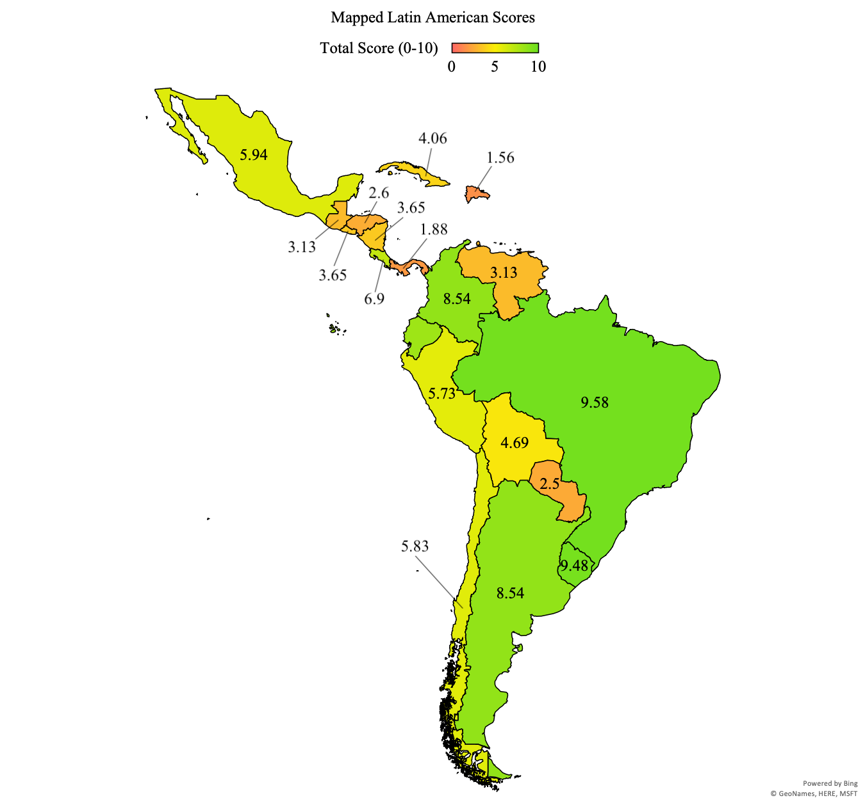
There were 304 possible points that could be earned by the countries measured in this project based on indicators from The Latin American LGBTQ Rights and Protections Index. The decriminalization and recognition category offered 95 possible points; the family rights and discrimination protection categories both offered 76 possible points; and the hate crime protections category offered 57 possible points. The countries included in the project received a total of 159.17 points out of the 304 possible (52.4%). They performed the best in the hate crime protections category, earning 36 out of 57 possible points (63%). The region performed nearly as well in discrimination protections as it did in hate crime protections, receiving 46.67 points out of 76 (61%). In the decriminalization and recognition category, Latin America received 51.5 out of 95 points (54%). Latin America’s worst performance occurred in the family rights category, having earned 25 of 76 possible points (32.9%). The data from the The Latin American LGBTQ Rights and Protections Index highlights the areas where Latin America excels—hate crime and discrimination protections—and the areas where there is plenty room for improvement—family rights.

South America
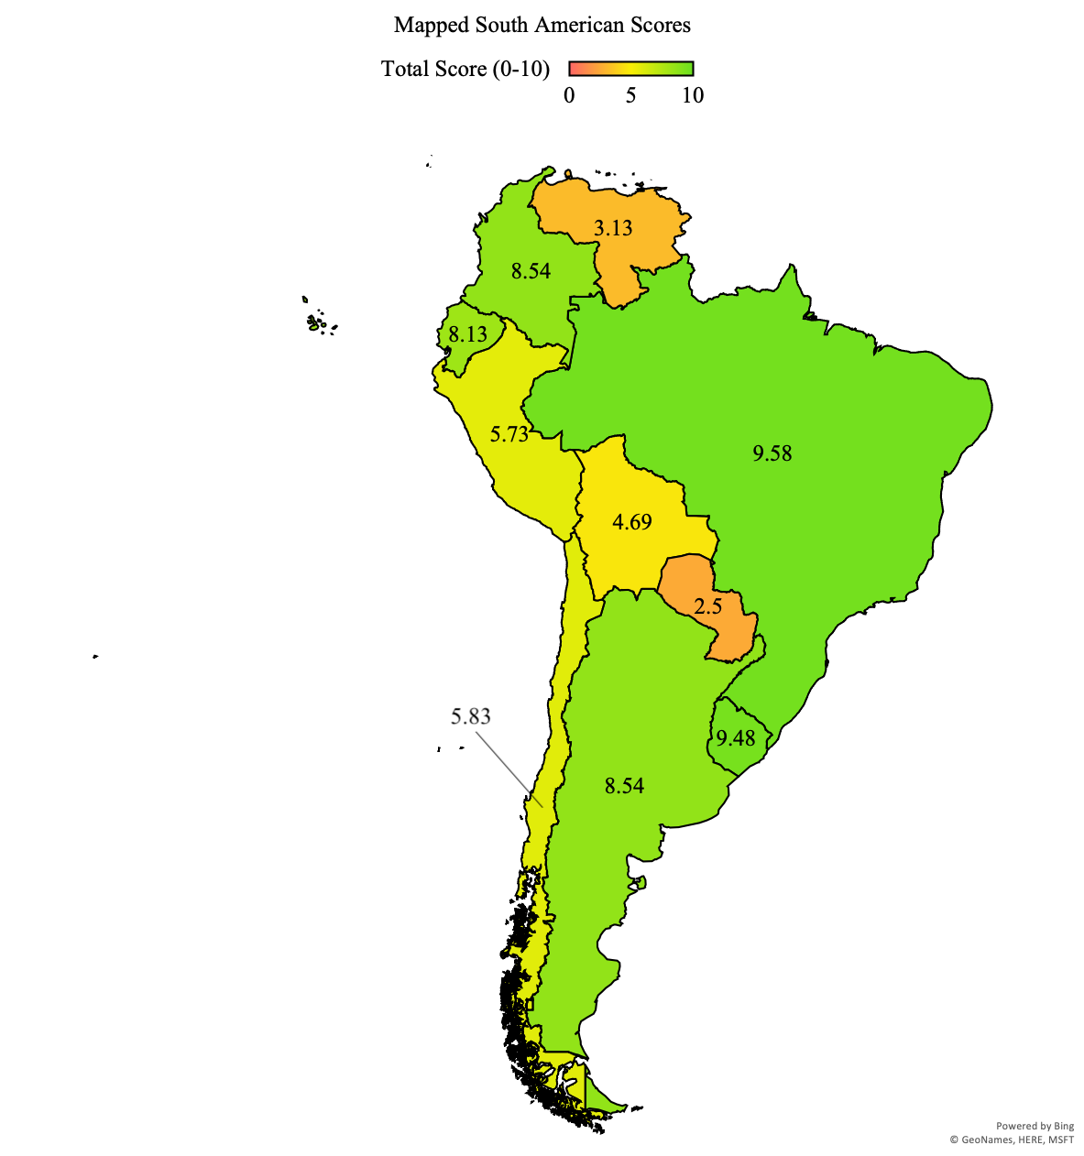
The average scaled score for South America based on the results from Table 3: Scored Index was 6.55 points out of 10 (65.5%), placing it well above the Latin American average of 5.24 points (52.4%). With 9.58 out of 10 scaled points (95.8%) Brazil was the highest scoring South American country, and also the highest scoring country from the entire dataset. The lowest scoring country from the region was Paraguay, which received 2.50 scaled points (25%). South America performed well in three of four categories: decriminalization and recognition, discrimination protections, and hate crime protections. In decriminalization and recognition, South America earned 34 of 50 possible points (68%); 19 of 40 possible points (48%) in family right; 27.83 of 40 possible points (70%) in discrimination protections; 24 of 30 possible points (80%) in hate crime protections; and 104.83 of 160 total possible points (66%).
All ten Spanish- and Portuguese-speaking countries measured in South America have legalized homosexuality, provide citizens with access to change their names and amend their gender marker on official government documents, and grant both discrimination protections and hate crime protections based on gender identity. Four countries from the region either ban or regulate conversion therapy, leaving six which do neither. Only two South American countries—Paraguay (25%) and Bolivia (40.6%)—do not have equal age of consent laws for same-sex and different-sex activity. Six countries in the region guarantee access to same-sex civil unions and four of those same countries also guarantee access to same-sex marriage. The four countries which grant joint-parent adoption—Brazil (95.8%), Argentina (85.4%), Colombia (85.4%), and Uruguay (94.8%)—also grant second-parent adoption.
The only country to not include sexual orientation as a basis for discrimination protection is Paraguay—though Brazil does not include sexual orientation at the federal level, many of its subnational units do. Four South American countries continue to prohibit queer or genderqueer people from enlisting in their armed forces. Bolivia (46.9%) and Venezuela (31.3%) are the only countries which continue to prohibit queer men, and/or individuals who have sex with queer men, from donating blood. Hate crime protections based on sexual orientation are only excluded in two counties: Paraguay (25%) and Venezuela (31.3%). Chile (58.3%) does not provide any hate speech restrictions, along with Paraguay, Venezuela, and Argentina.

Mexico
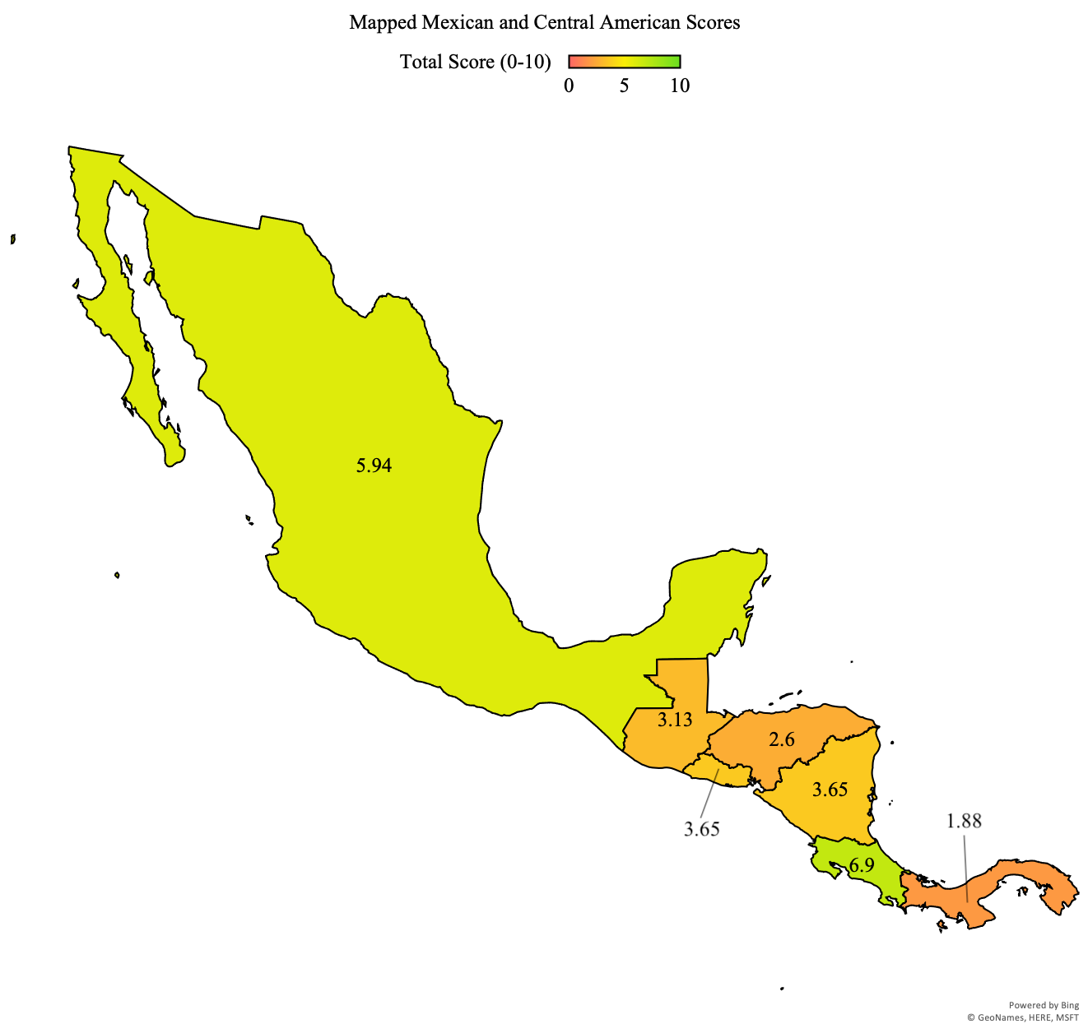
Mexico received 5.94 scaled points out of 10 (59.4%) in The Latin American LGBTQ Rights and Protections Index, outperforming the Latin American average of 5.24 scaled points (52.4%). Mexico’s penal code never criminalized homosexuality and there is no legislation or policy in place which bans or regulates conversion therapy. At the federal level, Mexico has equal ages of consent for both homosexual and heterosexual activity. Several subnational units provide citizens with access to change their legal names and amend the gender marker on their official government documents, which began in 2004.
Access to same-sex civil unions is not guaranteed at the federal level, though some subnational units began to provide access in 2007. The same is true for same-sex marriage. Similarly, some subnational units do grant access to same-sex marriage, but they did not begin to do so until 2009. The federal government does not guarantee access to joint- or single-parent adoption, but since 2010 some of the country’s subnational units have begun to do so. La ley federal para prevenir y eliminar la discriminación, passed in 2003, guarantees both discrimination protections and hate crime protections based on both gender identity, and also imposes hate speech restrictions. Queer and genderqueer individuals have never been prohibited from enlisting in Mexico’s armed forces. In 2012, a resolution was passed which lifted bans on blood donation from queer men and/or individuals who have sex with queer men. The same resolution does, however, include prohibitive requirements for blood donation.

Central America
Central America’s average score from The Latin American LGBTQ Rights and Protections Index was 3.63 scaled points out of 10 (36.3%). The highest scoring country from the region was Costa Rica, which received 6.88 scaled points (68.8%), and the lowest scoring country was Panama, with 1.88 scaled points (18.8%). All Central American countries have decriminalized homosexuality—the last to do so were Panama (18.8%) and Nicaragua (36.5%) in 2008, have equal ages of consent for same-sex and heterosexual activity, and allow queer men and/or people who have sex with queer men to donate blood. No countries in Central America ban or regulate conversion therapies. Two of the six countries from the region do not grant citizens access to change their legal name, and only one—Costa Rica (68.8%)—grants citizens access to amend the gender marker on their government documents.
Costa Rica is also the only country to provide access to same-sex civil unions. In fact, Costa Rica is the only Central American country to grant family rights—access to same-sex unions and marriage, joint-parent adoption, and single-parent adoption—to queer and genderqueer people. It is worth noting that there is currently a ban on same-sex marriage in Costa Rica, which also means that same-sex couples cannot receive all of the rights typically afforded to married couples. However, the Costa Rican legislature has approved a timetable for removing the ban before May of 2020. The only country to not provide discrimination protections based on gender identity is Panama, which—along with Guatemala (31.3%)—also does not provide discrimination protections based on sexual orientation. El Salvador (36.5%) is the only country in the region which allows queer and genderqueer individuals to serve in the armed forces, though it should be noted that neither Panama nor Costa Rica have a standing army. Panama is also the only Central American country to not provide hate crime protections based on real or perceived gender identity. The only two countries in the region to provide hate crime protections based on real or perceived sexual orientation are El Salvador and Nicaragua. No countries in Central America have hate speech restrictions.

The Caribbean
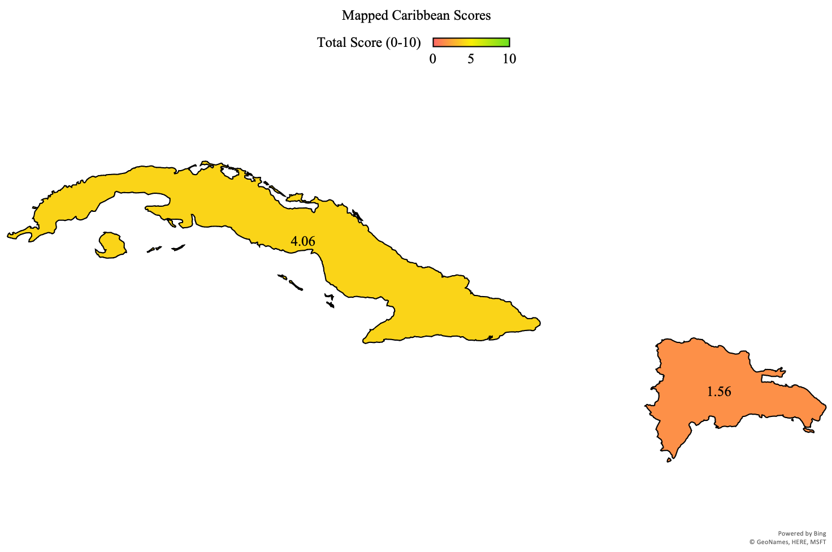
The average scaled score for the Caribbean based on The Latin American LGBTQ Rights and Protections Index was 2.81 scaled points out of 10 (28.1%). Cuba received 4.06 scaled points (40.6%) while the Dominican Republic received 1.56 scaled points (15.6%)—making the Dominican Republic the lowest scoring country in the entire index. Both Cuba and the Dominican Republic have decriminalized homosexuality, have equal ages of consent for homosexual and heterosexual activity, grant citizens the right to change their legal name, and allow queer men and/or people who have sex with queer men to donate blood. Neither country bans or regulates conversion therapy, guarantees access to same-sex civil unions or same-sex marriage, grants joint-parent adoption or second-parent adoption rights, provides hate crime protections based on real or perceived gender identity or sexual orientation, and neither country has hate speech restrictions. Cuba does allow citizens to amend their gender marker on government documents, though there are prohibitive requirements, and has lifted the ban which prevented queer and genderqueer people from serving in the armed forces.

CHAPTER 4: OBSERVING VARIANCE THROUGH ARGENTINA AND MEXICO
“When an individual is protesting society’s refusal to acknowledge his dignity as a human being, his very act of protest confers dignity on him”

—Bayard Rustin, n.d.

Much of the literature concerned with the development of LGBTQ rights and protections in Latin America suggests that Argentina and Mexico’s respective trajectories regarding the development of LGBTQ rights were similar to one another until the 2000s when both of their federal capitals passed legislation governing same-sex civil unions (Díez, 2018). This is not to say that both countries were expected to share the same path for the development of LGBTQ rights, rather their shared history suggested similar outcomes—one reason I elected to use Argentina and Mexico as the case studies for this project. Prior to the passing of this legislation and the ensuing divergence, one of the most important distinctions between the two countries was their democratic legacies.
For most of the 20th century Mexico was relatively free from military dictatorships, unlike Argentina where military intervention and dictatorship continually disturbed democratic rule until the 1980s. The legacies of military dictatorship and disrupted democracy have proven to have interesting effects on the state of modern LGBTQ rights and legislation in both countries. One of these effects is a renewed understanding of human rights and their importance in civil society, which became an instrumental tool for activists in Argentina in the wake of the country’s return to democracy in 1983. The role of activism in the development of Latin American LGBTQ rights and protections cannot be understated, as argued by Omar Encarnación. Just as important as activism in his framework surrounding the development of LGBTQ rights are transnationalism, constitutional reforms, and the pink tide (Encarnación, 2016). The following cases focus on these factors and how they were utilized by state and non-state actors alike in the development of LGBTQ rights and protections.

Argentina: Post-Transitional Victories and Burgeoning LGBTQ Rights
Argentina has continued to position itself as a leader in LGBTQ rights and protections among Latin American countries. This position is supported by data from The Latin American LGBTQ Rights and Protections Index, in which Argentina received 85.4% of the points possible—placing it well above the Latin American average of 52.4% and the South American average of 65.5%. Argentina’s higher-than average score reinforces its position as a regional leader for LGBTQ rights and justifies its focus as a case study in this project. The idea that Argentina has become a global leader for LGBTQ rights and protections since its return to democracy in the 1980s is especially powerful considering the historic dominance of Catholicism, machismo culture, and the country’s historical rejection of homosexuality. In the span of less than 40 years, Argentina has become a forerunner for LGBTQ rights and protections while other Latin American countries whose trajectories suggested they would hold this title —such as Mexico or Chile—have lagged behind.

The pink tide
The pink tide was felt more strongly in Argentina than other Latin American countries, mostly because of the profound economic and political crisis of 2001 which were credited to neoliberal policies enacted by previous administrations. The high degree to which Argentina experienced the pink tide helps to explain its position among Latin American states as an exemplar of LGBTQ rights. Argentina’s pink tide, again mostly an urban phenomenon, helped secure the election of Néstor Kirchner in 2003. After his election, the federal government and the country’s ruling party—El Partido Justicialista (JP)—adopted a rights-based agenda, focusing on human rights abuses and social policies (Friedman, 2018). The administration’s shifted focus was adopted by other governmental entities—both horizontally and vertically—which opened the door for LGBTQ groups to operate in a system which supported them more than previous governments (Strickler, 2017). This social focus continued with the election of Cristina Kirchner in 2007. It is through the continued state ally-ship offered by these socially focused bodies that we can observe where the pink tide, state, and non-state actors intersect. This intersection has had a profound effect on LGBTQ rights in Argentina—evidenced by the passing of the country’s 2010 same-sex marriage law, along with its 2012 gender identity law. Both of these measures, hailed across the globe, have been associated with the interaction between Argentina’s pink tide state and the LGBTQ activists who benefitted from the state’s refocused policies (Friedman, 2018). The degree to which the pink tide affected Argentina provides additional evidence as to why it finds itself among the top performers in the index.

Transnationalism

Global queering
In the wake of the HIV/AIDS crisis of the 1980s, national and international groups began to pressure the Argentine government to directly address the crisis. Díez notes that consistent pressure led to the successful passing of a federal law to devote effort towards combating the crisis, resulting in what would become a progenitor to the country’s modern LGBTQ rights (Díez, 2015). Prior to the state’s addressing of the HIV/AIDS crisis, there was a notable increase in stigmatization and “othering” of queer and genderqueer individuals—resulting in a period of LGBTQ demobilization. Not all of Latin America experienced the same national remedies that Argentina did in the aftermath of the HIV/AIDS crisis. The degree to which Argentina experienced state-based countermeasures was more significant than that of other countries. The Argentine government’s unique reaction worked in the favor of LGBTQ activists, which helps to further explain variance. Friedman proposes that the HIV/AIDS crisis helped to catalyze human rights advocacy and, in the case of Latin America, that state-based reactions strengthened LGBTQ movements while at the same time improving their visibility (Friedman, 2012). Thus, the HIV/AIDS crisis worked as a vehicle for individuals and organizations to remobilize themselves—simultaneously demanding countermeasures from the state, as well as sympathy and understanding from civil society at home and abroad—after the initial period of stigmatization.

International socialization
The work of international organizations, transnational groups, and other non-state actors in Argentina’s national arena were instrumental in the socialization of LGBTQ identities, easing the development of LGBTQ rights and protections. These transnational groups were able to affect policy debates at the national and international levels while lobbying for legal, social, and economic recognition. One of the most effective ways for these groups to incur change was through public shaming (Encarnación, 2016). The public shaming of both state and non-state actors proved an effective method for organization and activists alike to achieve their goals. Accordingly, the development of LGBTQ rights in Argentina came about as one effect of both national and international demands to reconcile past human rights abuses, as well as to normalize queer and genderqueer people in civil society. Afterall, it was in part because of the widespread trauma endured under El Proceso that LGBTQ activists and advocates in Argentina were inspired to remobilize so successfully after the nation’s return to democracy.

Transnational policy diffusion
Spain’s 2005 same-sex marriage law has been cited many times by scholars in the creation of same-sex marriage laws in other parts of the world, particularly those where Spain has ruled over colonies (i.e. most of Latin America). Friedman, like Encarnación, argues that Spain has been an important factor in the development of LGBTQ rights across Latin America, particularly with respect to marriage equality, the diffusion of norms, and sexual diversity rights. Legislators in Argentina referenced Spain’s same-sex marriage law during the construction of their own same-sex marriage bill in the late 2000s (Friedman, 2012). Transnational policy diffusion, however, can be traced back earlier in Argentina’s history of LGBTQ rights. In the 1990s, France and Spain both began to pass civil union laws which granted homosexual unions the same rights at heterosexual unions. Buenos Aires found inspiration in the lessons of its European counterparts and passed its own civil union law in 2002. Interestingly, policy diffusion is not always based on an ideology or a legal framework—sometimes it is based on financial incentives. This was seen during the late 2000s when, over the course of only a few years, Spain sent more than USD$150,000 to Argentina. During that time, the Argentina legislature was debating the formulation of a same-sex marriage bill after having recently observed a similar law being passed in Spain (Friedman, 2012; Encarnación, 2016). The willingness and receptiveness of Argentina’s legislatures, both federal and subnational, to blueprint their own legislation around pre-existing laws and international standards demonstrates how transnational policy diffusion plays into the development of LGBTQ rights.

Constitutional reform
Constitutional reforms in Argentina, at both the federal and subnational level, have been attributed to the development of LGBTQ rights. Apart from constitutional reforms which directly included LGBTQ rights, they have been effective in inciting continued positive development. At the subnational level, one of the most important and often-cited cases of constitutional reform that positively affected LGBTQ rights occurred in Buenos Aires in 1996. The 1996 reform incorporated anti-discrimination protections into the constitution, becoming the country’s first discrimination protection for LGBTQ people. It was this constitutional reformation, permitted by the federal government, which allowed for Argentina's first LGBTQ rights to be written into the country’s legal framework. Several years after its constitutional reform, Buenos Aires was able to pass a same-sex union law—the first for both Argentina and Latin America. At the federal level, Argentina has reformed its constitution a handful of times: several times in the late 19th century, then again in the mid 1950s, with the last reform occurring in 1994. One of the most important of these reforms for queer and genderqueer people was that of 1994, which introduced the amparo system. Argentina’s amparo system allows its citizens to file a procedure based on real or perceived violations of their constitutional rights, granting them direct access to the state’s judiciary. It is through this system that the state has continuously been challenged to recognize and protect the constitutional rights of Argentine citizens. Argentina’s national and subnational constitutional reforms and the country’s amparo system—one of few constitutional review systems in Latin America which non-state actors have access to—further explains why the country performed as it did in the index.

Activism
The continued presence of social movements in Argentina, and more broadly social activism as a whole, help to explain the country’s position as a leader for LGBTQ rights and protections (Encarnación, 2016). The history of social activism, and more specifically LGBTQ activism, in Argentina is a rich one. Of course, some movements have experienced serious setbacks and resistance—such as the oppression which many suffered under El Proceso—but they themselves have resisted erasure. An important feature of Argentine social movements and the activists which comprise them is their ability to remain visible while at the same time achieving concrete political advances. This is as an effect of a series of favorable conditions which came about after the 1980s: Argentina’s recent return to democracy, the subsequent increase in the popularity of human-rights discourse, and international support and diffusion of identity, culture, and community. These same conditions, discussed earlier in this chapter, explain just how impactful LGBTQ activists and organizations have been in the development of LGBTQ rights and protections. These conditions became the basis for the conscious strategic efforts of Argentinian activists to legitimize themselves in the eyes of civil society and to mobilize support for their cause, which allowed them to create both political and legal advances (Corrales & Pecheny, 2010). Social mobilization and political activism have been cited as two of the influential factors in the passing of Buenos Aires’ 1996 anti-discrimination legislation and its 2003 civil union legislation, giving credence to the idea that social activism has an important effect in the development of LGBTQ rights.

Mexico: Finding Success in the face of Co-Optation and Unitary Party Rule
While it might not be the paragon of LGBTQ rights that Argentina and Uruguay have become, Mexico has continued to make strides towards recognizing and protecting its queer and genderqueer community. Mexico received 59.4% of the points possible in The Latin American LGBTQ Rights and Protections Index, just outperforming the Latin American average of 52.4%. Mexico’s score from the index highlights its position as an intermediate performer when it comes to providing rights and protections to LGBTQ people. Like in other parts of Latin America, there exist cultural barriers—such as machismo and Catholicism—which have been responsible for the lagged embrace of LGBTQ rights and protections in Mexico. But unlike other Latin American nations, Mexico has been free of military dictatorship for most of the past century.

The pink tide
While still important in inducing state-based reactions to the failures of neoliberalism, the pink tide in Mexico had a much different effect in the development of LGBTQ rights and protections than it did in Argentina. The most notable distinction between Mexico and nearly all other Latin American countries, with respect to the pink tide, is that Mexico never really went left. At least not like other countries in the region. For the most part, Mexico has been ruled by center- and right-wing administrations since the rise of the pink tide in the late 1990s (Funk et al., 2017). While the federal government never really shifted towards the left, some Mexican subnational units did—most notably Mexico City. Mexico City offers the most pro-LGBTQ legislation and policy in all of Mexico, evidenced by the plethora of equal rights and protections it grants. The rise of the left in Mexico’s subnational units is key in understanding how the left remained competitive and influential despite never holding key administrative positions (Blofield et al., 2017). It is in the distinction between federal and subnational, specifically in the context of the urban pink tide and leftist governments, where we can observe another important factor in the uneven embrace of LGBTQ rights and protections in Mexico. Recognizing that Mexico’s federal government did not deviate to the left to the extent which other Latin American nations did—such as Argentina—helps to explain why Mexico’s performance in The Latin American LGBTQ Rights and Protections Index was intermediate. It also reinforces Encarnación’s approach to the role of the pink tide, or lack thereof, in the development of LGBTQ rights and protections.

Transnationalism

Global queering
The queering of Mexico, keeping in mind Encarnación's conceptualization of global queering, has been fueled by both internal and external forces. Moreover, Mexico’s queering has been impacted by the interaction between these forces. The HIV/AIDS crisis had a profound effect in the development of LGBTQ rights in Mexico. Arguably, the crisis had a greater effect in Mexico than it did in Argentina because of the way in which transnational and national LGBTQ groups operated for extended periods of time. These groups worked together with a high degree of engagement in the wake of the HIV/AIDS crisis—during which they sought a response from both the state and society as a whole. Because of their cooperation, international involvement in Mexico’s own domestic struggles has consistently been high—evidenced by Mexico City hosting Latin America’s first International AIDS Conference in 2006 (Encarnación, 2016). The continued relationship between Mexico’s domestic LGBTQ groups and their transnational counterparts in their efforts to produce a response from the state and civil society helps to explain how Mexico came to find itself in its current position with regards to LGBTQ rights.

International socialization
One historical feature that distinguishes Mexico from much of Latin America is its freedom from dictatorship, particularly during the 20th century. Where Mexico might not have suffered dictatorial rule, it has experienced unitary party rule under El Partido Revolucionario Institucional (PRI). Dictatorial rule had a deep-seated effect in the understanding of human rights, especially in cases where returns to democracy have been more recent—such as in Argentina. Because Mexico did not experience military dictatorship for most of the 20th century, the framing of LGBTQ rights and human rights was not as well received as it was in countries where activists and allies could remember what it was like to live under military rule. This is not to say that there were no human rights abuses under PRI, rather that anti-LGBTQ attitudes or actions did not find their origins unilaterally from the state and that they were not to the extent as those suffered under military dictatorships. It was because of Mexico’s perceived freedom from military dictatorship that international human rights groups discounted Mexico when they began to shift their focus from political imprisonment towards human rights abuses. Mexico’s perceived freedom, thus, led to less pressure from the same international groups which were working in countries like Argentina or Chile. This is not to say there were no human rights abuses in Mexico. In fact, several international groups continued to cover campaigns in several Mexican states that allowed police to harass and arrest queer people on the basis of immorality in the 1990s (Encarnación, 2016). In the style of other international organizations, the groups covering abuses in Mexico shame the state governments accused of human rights abuses in the international arena—leading to increased socialization of LGBTQ people.

Transnational policy diffusion
Mexico clearly follows Encarnación’s approach to transnational policy diffusion, evidenced by several key pieces of pro-LGBTQ legislation which have been passed in the last two decades. Encarnación himself notes the importance of Spain’s 2005 same-sex marriage law in the formulation of Mexico’s own same-sex marriage bill (Encarnación, 2016). Another piece of evidence which demonstrates the effect of international jurisprecedence in Mexico’s domestic legal framework is Mexico’s 2011 Human Rights Amendment. Broadly, the amendment was focused on justice reform and human rights standards. One of the most important articles of the amendment establishes that Mexico shall not sign on to any international treaty which disagrees with the human rights norms in the Mexican Constitution, as well as any treaty which the country has adopted. This article guarantees a wide range of human rights protections and creates a legal system of protection for the rights previously granted to the country’s population. More specific to Mexico’s LGBTQ communities, another article of the 2011 amendment expanded discrimination protections for queer and genderqueer Mexicans on the basis of international standards (Ek, 2012). These are just several samples of the many ways in which international jurisprecedence has affected Mexico. They strengthen Encarnacion’s concept of transnational policy diffusion while also helping to demonstrate Mexico’s score from The Latin American LGBTQ Rights and Protections Index.

Constitutional reforms
In Mexico, recent constitutional reforms have been incredibly impactful in producing developments in LGBTQ rights and protections. Complicating things for Mexico is the country’s non-central federal system—making it somewhat more difficult to pass and implement federal level reform. As previously discussed, Mexico’s 2011 human rights amendment greatly expanded discrimination protections on the basis of gender and sexuality, while also incorporating international human rights standards into the Mexican constitution. Several years prior to this series of constitutional reforms, though, Mexico’s congress sought to reform the legislature itself. One product of this reform was the introduction of Mexico’s amparo system—almost identical to that of Argentina. Ek explains that the Mexican amparo system is “the only constitutional procedure available to defend human rights violations” (Ek, 2012). Both the introduction of the amparo system and the 2011 reforms help to explain how, at the federal level, Mexico performed as it did.

Activism
Mexico’s legacy of social movements fits well into Encarnación’s activist framework and has done so since the early 1980s despite the temporary fluctuations in mobilization and resistance they have continued to face. The longevity of Mexico’s LGBTQ movements and the effects which they have had in the country’s legislature further strengthen the framework proposed by Encarnación. Mexican LGBTQ activists entered the political sphere in 1982 during the country’s transition to democracy, though it is important to acknowledge that these same movements first began to organize and mobilize nearly a decade prior (Corrales & Pecheny, 2010). The case of activism in Mexico is a unique one because of the country’s corporatist structure, where the federal government acts as an umbrella under which social, political, and economic groups operate through co-optation—losing power, while gaining representation (McGee, 2015). Because of the corporatist structure of Mexico’s federal government, it is clear that the country’s LGBTQ organizations traded power for representation. This is not to say that they lost all of their power, rather that they traded it for equal parts representation in a space where their presence had been historically rejected and treated as taboo. Co-optation of LGBTQ activism, then, helps to explain Mexico’s intermediate performance in The Latin American LGBTQ Rights and Protections Index.

CHAPTER 5: PUSHING FORWARD AND PROTECTING PROGRESS

“There will not be a magic day when we wake up and it’s now okay to express ourselves publicly. We make that day by doing things publicly until it’s simply the way things are”

—Tammy Baldwin, 2013

This project has worked to provide a broad historical background on the uneven embrace of LGBTQ rights and protection in Latin America, demonstrate the variance of these rights across the region, and offer an examination of this variance through the cases of Argentina and Mexico. Now in early 2020, the future of Latin American LGBTQ rights looks promising, but the future is never guaranteed. Democratic instability, the resurgence of both populism and conservative leadership, and the renewal of cultural barriers to LGBTQ rights in the region might prove to further the variance which already traverses Latin America. There are many factors in play when it comes to developing LGBTQ rights. Understanding how transnational factors—such as global queering, international socialization, and transnational policy diffusion—interact with state and non-state actors is instrumental in explaining how and why the observable variance of LGBTQ rights and protections in Latin America exists. On par with their transnational counterparts, domestic factors—namely, constitutional reforms, shifts towards the left (i.e. the pink tide), and activism—are also fundamental in explaining the variance of Latin American LGBTQ rights. The prospect of continued progressivism in Latin America is up in the air, but I will continue to hold onto the optimism which has fueled this project. The responsibility of maintaining and protecting the rights—and more importantly, the individuals and the communities—which have been established lies with all of us: activists, allies, communities, organizations, and governments alike.
While there is certainly much to be said for the progress that has been made with respect to Latin America’s LGBTQ rights, there is much work to be done at the social and cultural levels. Legislation and policy geared towards improving the lives of LGBTQ people are certainly important tools for improving their lives, but that same legislation and policy mean significantly less if the social and cultural attitudes towards the individuals whose lives they seek to improve are negative or disruptive. I cannot stress this idea enough. The reality in which much of the region’s LGBTQ communities live is contrasted by the rights and protections offered by states. Such as the case in Brazil, where trans women and gay men face some of the highest rates of violence in the world despite having some of the most broad and inclusive rights and protections.

Challenges to Development
Despite the continued progress that has been made in the name of LGBTQ rights, factors which inhibit this development have persisted and have, in some cases, been bolstered. I have come across some of these factors in my research, particularly conservative, religious, and cultural backlash. The resurgence of the populist right in Latin America and abroad will undoubtedly have an effect in the future of LGBTQ rights. Even now, we can see how populist-right leaders—such as Brazil’s Bolsonaro—have continued to use anti-LGBTQ rhetoric. Transitions from Catholicism to Evangelicalism will likely have a similar effect in the resistance of LGBTQ rights. As more Catholics find themselves disconnected or ostracized from an increasingly liberal religious community, they will surely choose to realign themselves with more conservative ones—namely Evangelicalism. Cultural barriers, likewise, will also play an important role in the negative response to the development of LGBTQ rights. The persistence of deep-rooted machismo, heteronormativity, and other cultural barriers will continue to prove an obstacle for LGBTQ activism and advocacy.
In the case of Argentina, conservative religiosity and the mythical figure of the gaucho—profoundly rooted in machismo—are two of the most impactful challenges to the development of LGBTQ rights and protections. Argentina has been free from right-wing leadership for much of its recent history, evidenced by the Kirchners holding office for nearly two-decades collectively. The story is similar in Mexico, where Catholicism and machismo are prevalent. It is my hope that the coupling of legal and social developments will prove effective in counteracting these and any other factors which have proved to be hurdles for the development of LGBTQ rights and protections.

WORKS CITED
Armario, C. (2019, June 14). AP Explains: The rocky rise of LGBT rights in Latin America. AP NEWS.
Blofield, M., Ewig, C., & Piscopo, J. M. (2017). The Reactive Left: Gender Equality and the Latin American Pink Tide. Social Politics: International Studies in Gender, State & Society, 24(4), 345–369.
Chiam, Z., Duffy, S. and González Gil, M. (Eds.). (2017). Trans Legal Mapping Report 2017: Recognition before the law. International Lesbian, Gay, Bisexual, Trans and Intersex Association, 7-115.
Corrales, J. (2017). Understanding the Uneven Spread of LGBT Rights in Latin America and the Caribbean, 1999-2013. Journal of Research in Gender Studies, 7(1), 52–82.
Corrales, J. (2019). The Expansion of LGBT Rights in Latin America and the Backlash. In M. J. Bosia, S. M. McEvoy, & M. Rahman (Eds.), The Oxford Handbook of Global LGBT and Sexual Diversity Politics. Oxford University Press.
Corrales, J., & Pecheny, M. (Eds.). (2010). The politics of sexuality in Latin America: A reader on lesbian, gay, bisexual, and transgender rights. University of Pittsburgh Press.
Democracia Abierta. (2019). #50AñosStonewall: Siguen los ataques a la comunidad LGBT+ en América Latina. OpenDemocracy.
Díez, J. (2018). Institutionalizing Same-Sex Marriage in Argentina and Mexico: The Role of Federalism. In B. Winter, M. Forest, & R. Sénac (Eds.), Global Perspectives on Same-Sex Marriage: A Neo-Institutional Approach (pp. 19–38). Springer International Publishing.
Encarnación, O. G. (2016). Out in the Periphery: Latin America’s Gay Rights Revolution. Oxford University Press.
Friedman, E. J. (2012). Constructing “The Same Rights with the Same Names”: The Impact of Spanish Norm Diffusion on Marriage Equality in Argentina. Latin American Politics and Society, 54(4), 29–59.
Friedman, E. J. (Ed.). (2018). Seeking Rights from the Left; Gender, Sexuality, and the Latin American Pink Tide. Duke University Press.
Funk, K. D., Hinojosa, M., & Piscopo, J. M. (2017). Still Left Behind: Gender, Political Parties, and Latin America’s Pink Tide. Social Politics: International Studies in Gender, State & Society, 24(4), 399–424.
HRC (n.d.). The Lies and Dangers of “Conversion Therapy.” Human Rights Campaign.
Madrigal-Borloz, V. (2019). United Nations, General Assembly, Report of the Independent Expert on protection against violence and discrimination based on sexual orientation and gender identity, A/74/181, 3-25
Mendos, L. R. (Ed.). (March 2019). State-Sponsored Homophobia 2019. International Lesbian, Gay, Bisexual, Trans and Intersex Association, 11-536.
Mendos L. R. (Ed.). (December 2019). State-Sponsored Homophobia 2019: Global Legislation Overview Update. International Lesbian, Gay, Bisexual, Trans and Intersex Association, 9-178.
Mineo, L. (2019). U.N. report takes global look at LGBT violence and bias. Harvard Gazette.
Moloney, A. (2019). LGBT+ murders at “alarming” levels in Latin America—Study—Reuters.
NCLR. (2014, June 16). Born Perfect: The Facts About Conversion Therapy. National Center for Lesbian Rights.
Smith, P. H. (2012). Democracy in Latin America: Political change in comparative perspective (2nd ed). Oxford University Press.
Strickler, J. (2017). Variation in Latin American LGBT Rights [University of Miami].
Wang, J. (2018). Ban the Ban: An argument against the 12 month blood donation deferral for men who have sex with men / GLAAD.
Wilets, J. D. (2010). From Divergence to Convergence—A Comparative and International Law Analysis of LGBTI Rights in the Context of Race and Post-Colonialism. Duke Journal of Comparative & International Law, 3, 631–686.
Wolvers, A., Salverda, T., Schwarz, T., & Tappe, O. (2015). Concepts of the Global South: Vol. 2015/1 (A. Wolvers, T. Salverda, T. Schwarz, & O. Tappe, Eds.). Global South Studies Center Cologne.

APPENDICES
"If it wasn't for the drag queen, there would be no gay liberation movement”
—Sylvia Rivera, 1973

Appendix A: Composite Case Study Indices

Appendix B: Composite South American Indices

Appendix C: Composite Central American Indices

Appendix D: Composite Caribbean Indices

Appendix A: Composite Case Study Indices

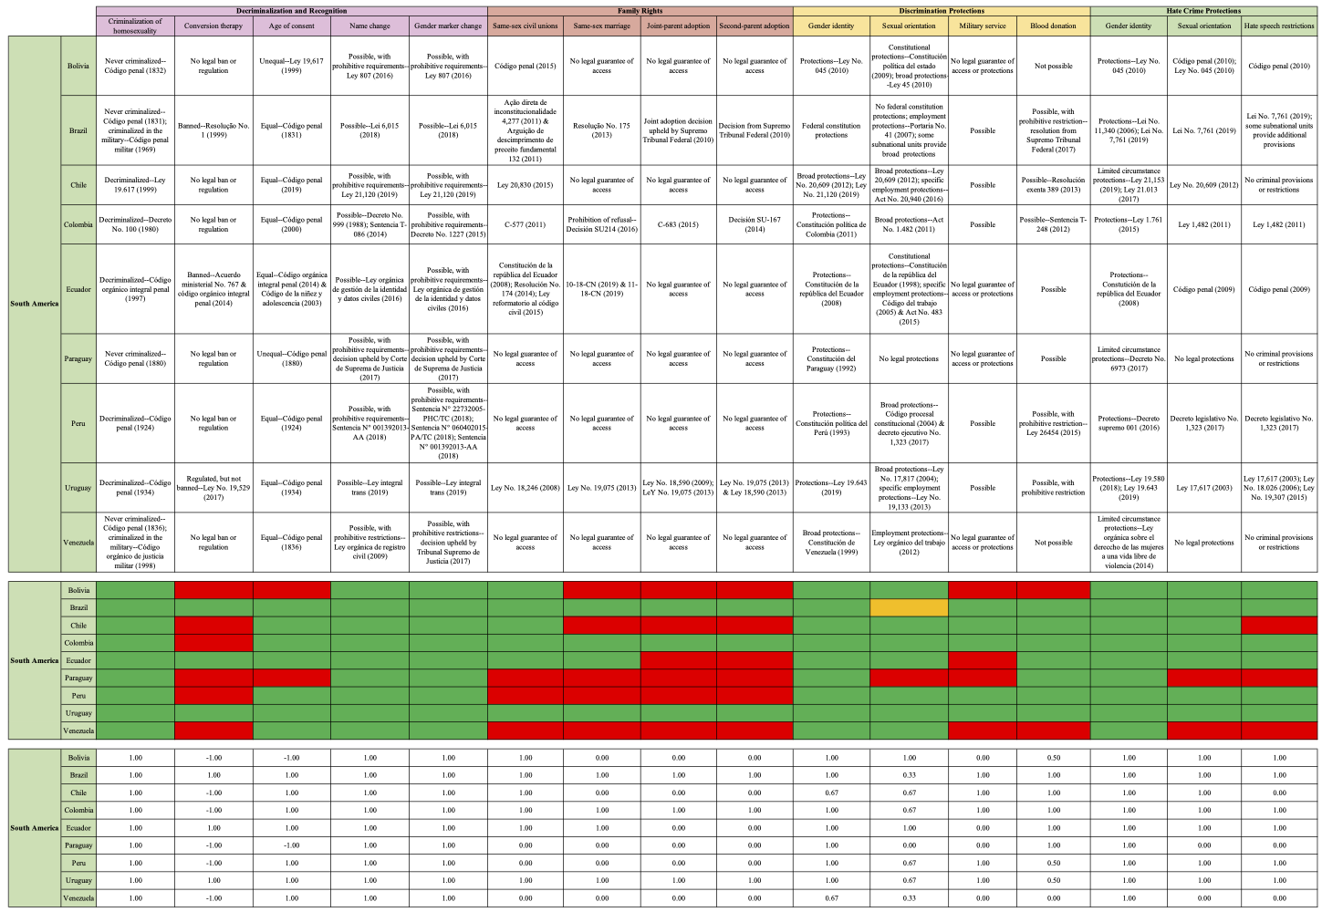
Appendix B: Composite South American Indices

Appendix C: Composite Central American Indices

Appendix D: Composite Caribbean Indices

Tables
Table 1: Earned points vs. possible points for Latin America
Decriminalization and Recognition | Family Rights | Discrimination Protections | Hate Crime Protections | Total
51.50/90 (57.2%) | 25/76 (32.9%) | 46.67/76 (61.4%) | 36/57 (63.2%) | 159.17/304 (52.4%)

Table 2: Earned points vs. possible points for South America
Decriminalization and Recognition | Family Rights | Discrimination Protections | Hate Crime Protections | Total
34/50 (68%) | 20/40 (50%) | 27.83/40 (69.6%) | 24/30 (80%) | 105.83/160 (66.1%)

Table 3: Earned points vs. possible points for Mexico
Decriminalization and Recognition | Family Rights | Discrimination Protections | Hate Crime Protections | Total
2/5 (40%) | 2/4 (50%) | 3.5/4 (75%) | 2/3 (67%) | 9.5/16 (59%)

Table 4: Earned points vs. possible points for Central America
Decriminalization and Recognition | Family Rights | Discrimination Protections | Hate Crime Protections | Total
11/30 (36.7%) | 3/24 (12.5%) | 13.83/24 (57.6%) | 7/18 (38.9%) | 9/96 (36.3%)

“Queer” functions as an interchangeable, umbrella term for any person with a marginalized sexual orientation (e.g. gay, lesbian, etc.)
“Genderqueer” functions as an interchangeable, umbrella term for any person who is gender non-conforming or non-binary, and whose gender identity and/or gender expression differs from what is typically associated with the sex they were assigned at birth (e.g. trans, intersex, etc.)
I have elected to use “LGBTQ” in place of a longer acronym because the legislation and policies which are studied in this project have sought to combat inequality and eliminate discrimination, hate, and violence are focused on gender identity and sexual orientation; “LGB” and “Q” describe the sexual orientation of lesbian, gay, bisexual, and queer individuals, respectively; “T” describes individuals whose gender identity and/or gender expression differs from what is typically associated with the sex they were assigned at birth
“Global south” is a term conceived by the World Bank, which describes countries with (1) low to middle rates of income, as compared to those of the Global North; (2) a history of colonialism; and (3) low-quality democracies (Wolvers et al., 2015, 1)
“Post-transitional period” describes the era of democratization which began in Latin America after the decline of dictatorial rule and oppressive authoritarian regimes in the 1970s and 1980s
“Global queering” describes the diffusion of Western—typically American—gender and sexual identities through globalization and cultural hegemony.
All indices can be found in the Appendix where they are compiled into their respective regions; see Appendix A: Composite Case Study Indices, Appendix B: Composite South American Indices, Appendix C: Composite Central American Indices, and Appendix D: Composite Caribbean Indices
“Positive” describes the legislation and policy which have a beneficial or constructive impact on the lives of queer and genderqueer individuals.
“Negative” describes the legislation and policy which have a detrimental or harmful impact on the lives of queer and genderqueer individuals.
“Scaled score” describes the score which was found by multiplying each country’s original index score by .625 to adjust them to fit within a 0 to 10 scale; the same scores were used to create the mapped figures (see appendix and Figures 1-4).
“Percentage score” describes the percentage of points earned by each country or region in a given category or indicator and was found by dividing earned points by possible points.
“Possible points” describes the total possible points from Table 3, where each country received a base score from anywhere between -4 and 16; the sum of those possible points 304 for Latin America, 160 for South America, 16 for Mexico, 96 for Central America, and 32 for the Caribbean

